Details about my report:-
Header line1 (In red color and Underline) :- I have used Text box and for date (Dec-2015)I have use List box.
Header Line2:- I have use text box ( for Target, Actual, Plan Variance ,YOY variance, YE Target, Actual Vs Target.)
Value under Header line2 (Target) :- For Each list table I have use Text box as row details/Metric (like M2- Digitally engaged customers ).
Used list box for numeric value for each details/Metric under Vertical Container for header Target, Actual, Plan Variance ,YOY variance, YE Target
Under heading Actual vs. Target: - I have used Graph

In section properties I have used Layout Precision and Uncheck fit to screen option.
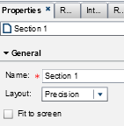
When I had created this report in Report designer the Browser Zoom size was 75%
In Report Viewer in 75% zoom it look good.
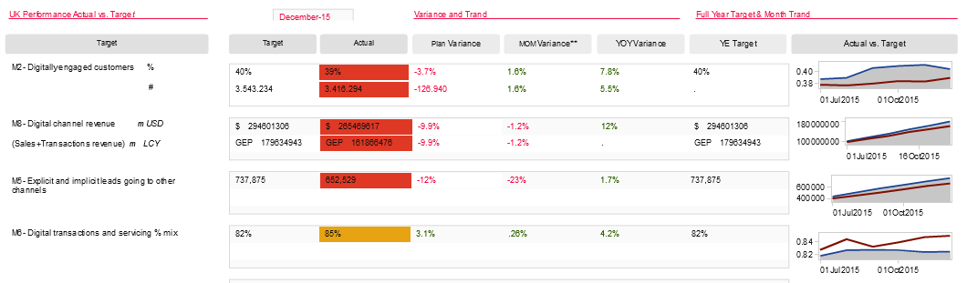
But when I am trying to Zoom in and Out the report structure not look good, for example I have use 100% zoom and report look lie below screenshot.
