In Report viewer the repot look nice but when I am trying to export that report in PDF file then it’s not look same as Report viewer.

I have used use **Expend Clipped content**  and page size A3 or A4.

It also not looks good Without **Expend Clipped content**

Report look on SAS VA report viewer

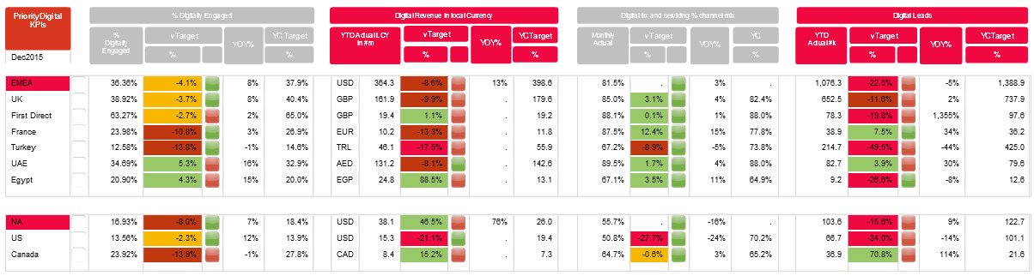

Report look on PDF file.

