Unicode test file on SAS server
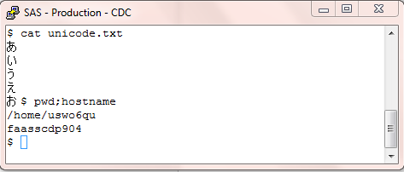

SAS EG Code, which trying to read file from server and to display it in SAS EG
DATA WORK.unicode ( encoding='utf-8');
INFILE '/home/uswo6qu/unicode.txt'
LRECL=256
ENCODING="UTF-8"
DLM='2c'x
MISSOVER
DSD ;
INPUT
F1 : $CHAR1. ;
RUN;

SAS EG Output:
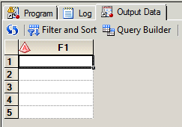

SAS EG Log:
1 ;*';*";*/;quit;run;
2 OPTIONS PAGENO=MIN;
3 %LET _CLIENTTASKLABEL='unicode test';
4 %LET _CLIENTPROJECTPATH='/User Folders/Naga Maturi/My Folder/unicode_test.egp';
5 %LET _CLIENTPROJECTNAME='unicode_test.egp';
6 %LET _SASPROGRAMFILE=;
7
8 ODS _ALL_ CLOSE;
9 OPTIONS DEV=ACTIVEX;
10 GOPTIONS XPIXELS=0 YPIXELS=0;
11 FILENAME EGSR TEMP;
12 ODS tagsets.sasreport12(ID=EGSR) FILE=EGSR STYLE=Analysis
12 ! STYLESHEET=(URL="file:///C:/Apps/SAS/x86/SASEnterpriseGuide/4.3/Styles/Analysis.css") NOGTITLE NOGFOOTNOTE
12 ! GPATH=&sasworklocation ENCODING=UTF8 options(rolap="on");
NOTE: Writing TAGSETS.SASREPORT12(EGSR) Body file: EGSR
13
14 GOPTIONS ACCESSIBLE;
15 DATA WORK.unicode ( encoding='utf-8');
16 INFILE '/home/uswo6qu/unicode.txt'
17 LRECL=256
18 ENCODING="UTF-8"
19 DLM='2c'x
20 MISSOVER
21 DSD ;
22 INPUT
23 F1 : $CHAR1. ;
24 RUN;

INFO: Data file WORK.UNICODE.DATA is in a format that is native to another host, or the file encoding does not match the session
encoding. Cross Environment Data Access will be used, which might require additional CPU resources and might reduce performance.
NOTE: The infile '/home/uswo6qu/unicode.txt' is:
Filename=/home/uswo6qu/unicode.txt,
Owner Name=uswo6qu,Group Name=itbi,
Access Permission=rw-r--r--,
Last Modified=Wed Aug 31 16:30:00 2016,
File Size (bytes)=19

WARNING: A character that could not be transcoded was encountered.
WARNING: A character that could not be transcoded was encountered.
WARNING: A character that could not be transcoded was encountered.
WARNING: A character that could not be transcoded was encountered.
WARNING: A character that could not be transcoded was encountered.
NOTE: 5 records were read from the infile '/home/uswo6qu/unicode.txt'.
The minimum record length was 1.
The maximum record length was 1.
NOTE: The data set WORK.UNICODE has 5 observations and 1 variables.
NOTE: DATA statement used (Total process time):
real time 0.01 seconds
cpu time 0.00 seconds

25
26 GOPTIONS NOACCESSIBLE;
27 %LET _CLIENTTASKLABEL=;
28 %LET _CLIENTPROJECTPATH=;
29 %LET _CLIENTPROJECTNAME=;
30 %LET _SASPROGRAMFILE=;
2 The SAS System 03:43 Thursday, September 1, 2016

31
32 ;*';*";*/;quit;run;
33 ODS _ALL_ CLOSE;
34
35
36 QUIT; RUN;
37

