Improvement Request:

Adding a Column for Search Criteria in the SAS Visual Investigator Audit Report

Hello!
I need your help. As an administrator of SAS Visual Investigator, I need to audit the actions performed by users. One of the most important actions performed is 'Search'. Below, I present Figure no. 1 of the report that is generated during the audit of the searches conducted."
Figure 1
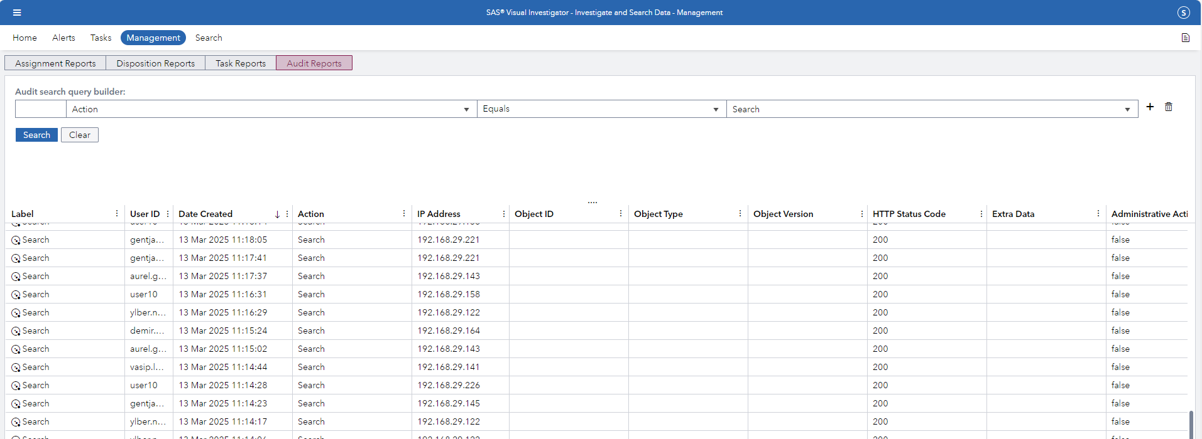

"In its current form, SAS Visual Investigator does not display the search criteria used by the user to perform a search. This criterion is only displayed if we double-click on a record. This is shown in Figure no. 2."
Figure 2
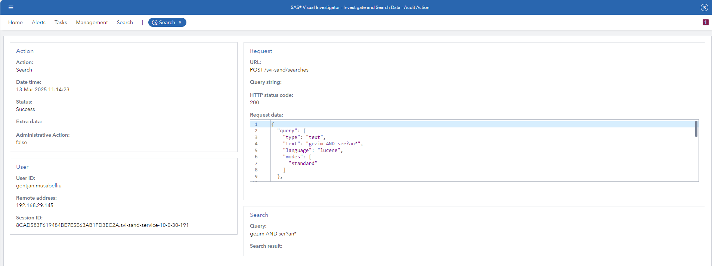

"Monitoring the search criteria by opening each record takes time and, moreover, does not allow you to find out if a user has searched for a specific record. What I would like is: Can we display the search criteria used by users as a separate column in the report generated during the audit, as shown in Figure no. 1?
I greatly appreciate your response."

I am using this version of SAS Visual Investigator.

