I tried to run Link analysis node of eMiner, but I got run time error message.
Let me know how to fix it.
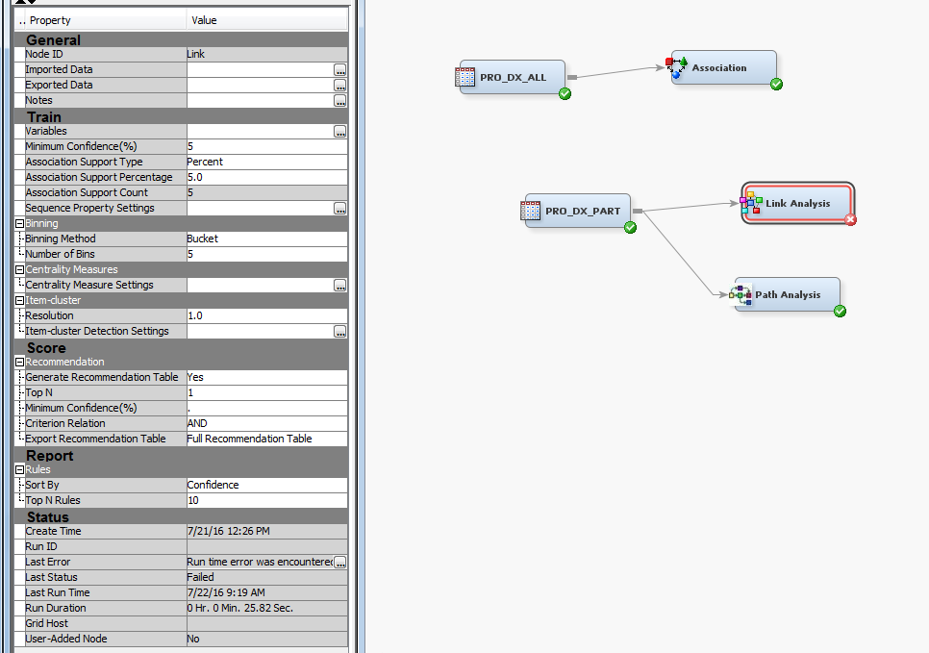
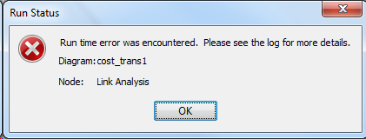

NOTE: The file _WIPCHK is:
Catalog Name=EMWS1.ASSOC.TEST.SOURCE,
Catalog Page Size=4096,
Number of Catalog Pages=11,
Created=Thu, Jul 21, 2016 10:26:47 AM,
Last Modified=Fri, Jul 22, 2016 09:19:01 AM,
Filename=E:\cost_transparency\Ass_Dx\Workspaces\EMWS1\assoc.sas7bcat,
Release Created=9.0401M2,Host Created=X64_7PRO

NOTE: 1 record was written to the file _WIPCHK.
The minimum record length was 10.
The maximum record length was 10.
NOTE: DATA statement used (Total process time):
real time 0.21 seconds
cpu time 0.01 seconds

7160 data _null_;
7161 rc = fdelete('_wipchk');
7162 run;

NOTE: DATA statement used (Total process time):
real time 0.20 seconds
cpu time 0.00 seconds

7163 filename _wipchk;
NOTE: Fileref _WIPCHK has been deassigned.
7164 filename _wipxml 'C:\Users\e42995\AppData\Local\Temp\SAS Temporary Files\_TD8812_Y0274_\Prc2\DiagramOpenSessionResponse.xml' encoding="UTF-8" NOBOM;
7 The SAS System 09:18 Friday, July 22, 201
6

WARNING: End of file.
WARNING: End of file.

